

May 6, 2020

Dear Parents/Guardians,

On May 4, 2020 Governor Murphy announced that all New Jersey school buildings would remain closed for in-person instruction for the remainder of the 2019-2020 school year. Our staff will continue to provide support, remote learning and services until the last day of school. There will be no remote instruction on Monday, May 25, 2020 in observance of Memorial Day. Since our school did not use any snow days, the last day of school will be Tuesday, June 16, 2020. When appropriate we will also make arrangements to honor our graduates with a ceremony at some point in the future.
Governor Murphy and the Department of Education have not made any decisions yet if school buildings will be permitted to open for the Extended School Year summer program. We will continue to follow the government guidelines and are working with the County Offices of Education to develop a preliminary outline for the delivery of summer services.
I have also included the calendar for the 2020-2021 school year.

I will continue to keep our school community updated with all important information. Thank you as always for your support, cooperation, and understanding during these times.

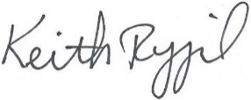
Stay safe and stay strong,

Keith Rygiel
Principal

