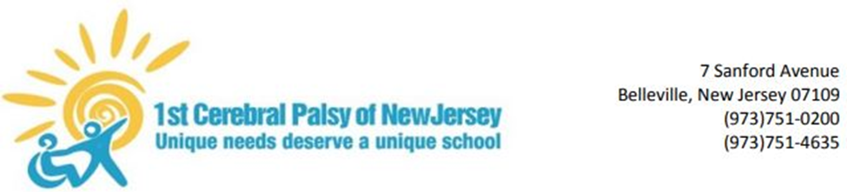

1st Cerebral Palsy of NJ – School Health Related Closure Plan
Updated May 22, 2020

Addendum 1: Essential Employees List
Employee Name | Job Title
Patrick Colligan | Executive Director
Keith Rygiel | Principal
Danielle Van Beuzekom | Human Resources
Bogdan Benning | Business
Mary Brennan | Social Worker
Barbara Uwuimwonse | School Nurse
Antonia Tierney | Teacher
Karen Tensfeldt | Teacher
Kim Alessio | Teacher
Theresa Bielitz | Teacher
Brian Perlstein | Teacher
Liliana Sage | Teacher
Noelle King Bellitti | Teacher
Caroline Conklin | Teacher
Rose Canova | Teacher
Kim Catalfamo | Teacher
Lifflefinger Andrek | Transition Coordinator
Joanne Bundonis | Physical Therapist
Lynda Man Bos | Physical Therapist
Katie Lennon | Physical Therapist
Jessica Palermo | Physical Therapist
Kayla Patterson | Occupational Therapist
Maeve Kirwan | Occupational Therapist
Maureen Costello | Occupational Therapist
Margaret Modero | Occupational Therapist
Maria Serrano | Occupational Therapist
Kim Kerney | Speech Therapist
Megan Hester | Speech Therapist
Francesca Morin | Speech Therapist
Carly Truglio | Speech Therapist
Ricardo Coutinho | Maintenance
Mark Botelho | Maintenance
Darren Zow | Maintenance
Nicholas Sanducci | Maintenance
Tanya Ayala | Office
Eileen Abate | Office
Ana Amador | Office

