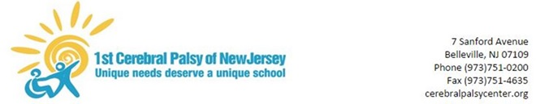

April 8, 2020

Dear Parents/Guardians,
As we complete the fourth week of distance learning, I wanted to check in again to discuss our current plan. First, we continue to see great collaboration between our families and staff. Our teachers and therapists are showing a tremendous amount of initiative, creativity, and flexibility to provide support. We will continue to monitor and address any unique challenges we may encounter.
Next, Spring Recess will be from April 10th through April 17th. Remote instruction will not take place during this period. I would encourage everyone - students, families, and staff, to take this opportunity to “unplug.” Use this break to take a breath as we prepare to come back “online” with renewed energy after Spring Recess on April 20th.
Our staff has prepared additional materials which will be sent home for weeks 5-6 of remote learning. Please do your best to work with our staff and respond to and acknowledge any correspondences. Also, as a reminder that while school is closed, Doctor’s Cheng and Shoval are available for telemed appointments by either calling 1-888-244-5373 or emailing physiatry@childrens-specialized.org
We have no new information about when schools will reopen for students, so remote instruction will resume after Spring Recess on April 20th. Governor Murphy and his administration will not assess the reopening of schools until at least April 17, 2020, at the earliest. The federal government has recommended nationwide social distancing, and will not reassess its recommendation until April 30th, at the earliest. The NJ Commissioner of Education specifically asked that school administrators refrain from announcing or speculating about school reopening dates unless they are directed to do so by the Governor. The Governor has emphasized that the decision to reopen schools will be based information and advice from public health and safety experts, and in consultation with educators and school districts.
We will continue to work together to face this challenge for as long as we need to.
As always, thank you for your cooperation. Stay strong and stay safe,

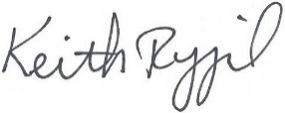

Keith Rygiel
Principal

