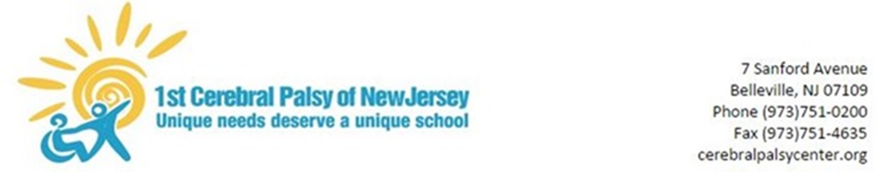

April 27, 2020

Dear Parents/Guardians,

The Governor recently announced that all New Jersey schools will remain closed and operate remotely through at least May 15th. Our staff will continue to update and send materials to provide your children with the most appropriate services during this time.

There are no other major updates to report, so I just wanted to again take the opportunity to thank all of our students, families, and staff for their incredible efforts. I had the opportunity to sit-in on one of our classroom’s virtual lessons and it was great to see our students and staff smiling and continuing the high level of engagement. Our school motto is – “Unique Needs Deserve a Unique School” – and at no time has that been more suitable than now. We will succeed while working together during these unique times.

I hope you and your loved ones are all happy and healthy. We will continue to support each while moving forward.

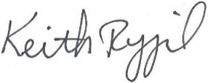
Stay safe and stay strong,

Keith Rygiel
Principal

