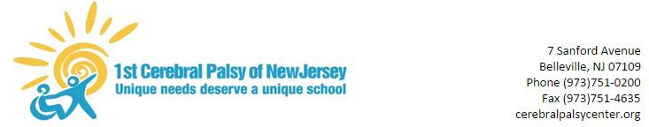

Home Instruction Preparedness Survey

The NJ Department of Education has instructed schools to develop a home instruction plan in the event that the Department of Health directs schools to close for health-related risks. To help us prepare the home instruction plan, please complete this brief survey and return it to school.

Student’s Name:_________________________

Your Name: ____________ Your Email Address:_______________

1. Does your student have access to the internet at home to view/complete assignments in the event of a school closure?
Yes

No

2. My student has access to the following internet-ready devices which can be used at home (check all that apply).

Desktop iPad/Tablet

Laptop Other__________

Chromebook None

