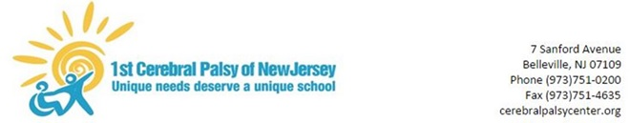

March 10, 2020

Dear Parents/Guardians,

The purpose of this letter is to provide an update regarding the recent developments pertaining to the possible spread of the Novel Coronavirus (COVID-19). Over the past week, I have participated in several meetings and conference calls with district administrators and supervisors to keep our school prepared. Although the health and safety of our students and staff is always a priority, we must take extra efforts during this unique time to reduce the transmission of illness. I would like to share the following information with you:

- Effective immediately and until further notice: All non-essential school trips have been postponed

- Effective immediately and until further notice: All non-essential visitors and extracurricular events in the building have been postponed (including family night and the afterschool program)

- Our maintenance department has purchased several electrostatic spray cleaners to assist in the efforts to sanitize, disinfect, and clean the building.
- As a precautionary measure the Department of Education has mandated schools to prepare a plan for dealing with a potential prolonged closure. Since we already have an early dismissal, staff training day scheduled for this Wednesday 3/11/20 it will be used by our staff to plan and prepare materials for each student. Please complete the attached survey to help our staff prepare a plan.
During these unprecedented times we will continue to be flexible and work together as a team to the best of our abilities. Thank you in advance for your cooperation.
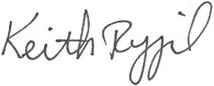

Keith Rygiel
Principal

